REDD APPRON CATERING

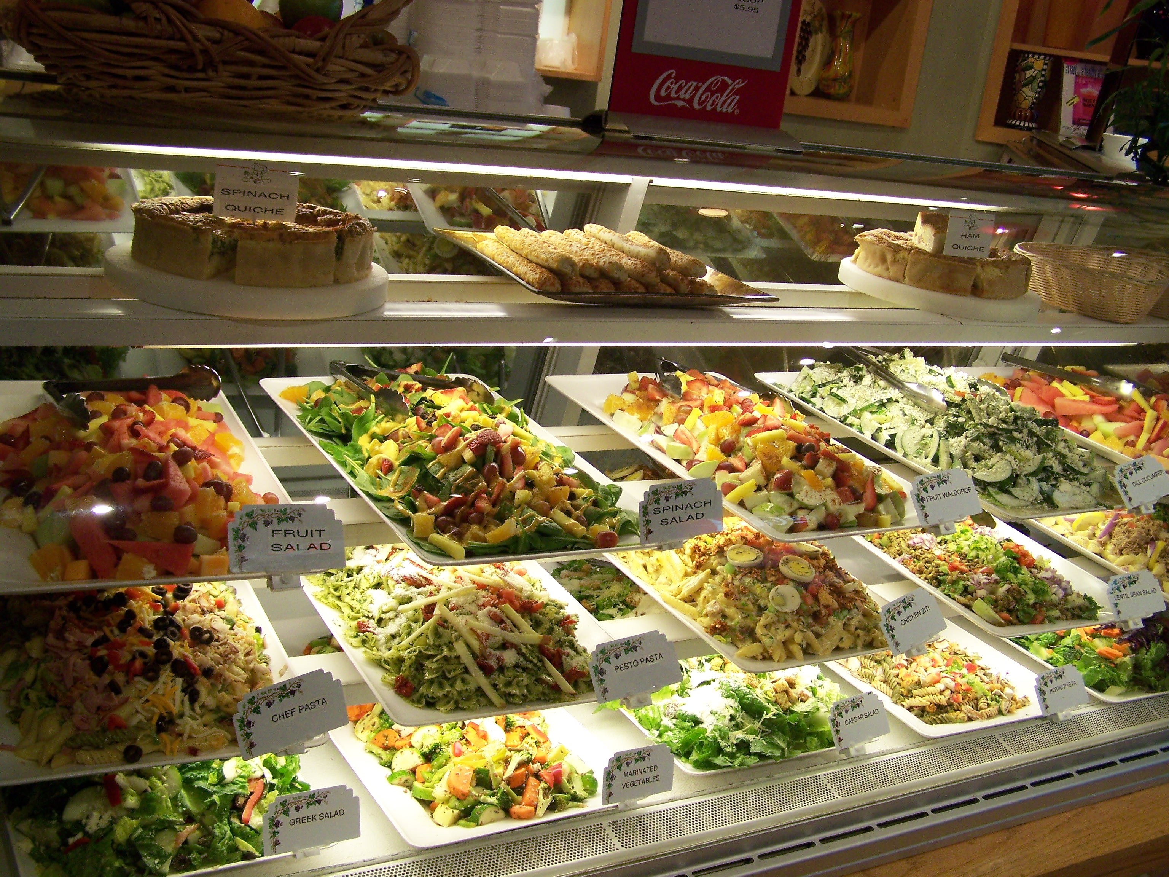Salads
Chicken Ziti Salad
Penne pasta, diced celery, tomatoes and cut chicken breast mixed with Honey Mustard and Caesar Dressing, tossed with Euro Spices.
Caesar Salad
Fresh romaine lettuce, croutons and grated parmesan cheese, served with creamy Cesar Dressing.
Garden Salad
Fresh chopped romaine lettuce, mixed with cucumbers, tomatoes, fresh vegetables, served with House Dressing.
Classic Greek Salad
Fresh chopped romaine lettuce, mixed with cucumbers, tomatoes, bell peppers, pepperoncini, red onions, Kalamata olives, and feta cheese, served with signature Greek Dressing.
Tuna Pasta Salad
Fresh cooked shell pasta mixed with tuna, diced tomatoes and celery, bell peppers and low fat mayonnaise.
Pesto Pasta Salad
Fresh cooked bowtie pasta mixed with our signature Pesto Dressing, tomatoes ,parmesan cheese and diced sun dried tomatoes.
Fresh Lentil Bean
Cooked lentil beans with chopped romaine lettuce, diced red onions and tomatoes, tossed with House Dressing.
Dill Cucumber
Fresh cut cucumbers, romaine lettuce, diced tomatoes, and dill weed tossed with special Ranch Dressing and topped with Feta Cheese.
Marinated Vegetables
(Full of Vitamins and Minerals)
Diced celery ,Zucchini ,yellow squash ,red bell pepper ,green peppers, sliced carrots ,cut broccoli and pepperoncini, tossed with our signature House Dressing.
Chef Pasta Salad
A mixed of shell pasta, rainbow rotini, bowtie and penne [pasta copped romaine and black olives tossed with Caesar, Honey Mustard, Ranch Dressing, garnished with julienne cut Ham, Turkey, and mild Cheddar Cheese.
Rainbow Rotini Salad
Fresh cooked tricolor pasta farfila mixed with vegetables tossed with our signature House Dressing, garnished with julienne cut Ham and Turkey.
Spinach Waldorf Salad
Fresh cut baby spinach , strawberries,grapes, raisins, oranges,pineapple, Honey Mustard Dressing and a touch of ground cinnamon.
Serving size and prices:
12" (Approx 8-10 servings) $30.00
16" (Approx 12-18 servings) $40.00
18" (Approx 20-25 servings) $50.00
Apple Waldorf (Seasonal)
Fresh cut red and green apples mixed with low fat mayonnaise a touch of sugar substitute, garnished with strawberries,grapes,oranges, pineapple, raisins, and a touch of ground cinnamon.
Fresh Fruit Salad(Seasonal)
A Fresh cut assortment of seasonal fruits.
Serving size and prices:
12" ( Approx 8-10 servings) $35.00
16" (Approx 12-18 servings) $45.00
18" (Approx 20-25 servings) $55.00

Banquets and Catering
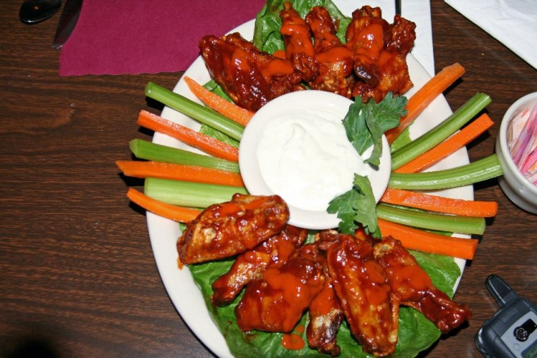
Ala Carte Entrees | half | full
Penne with Tomato Sauce | $24.95 | $47.95
Baked Penne | $32.95 | $63.95
Penne Shrimp & Broccoli | $39.95 | $77.95
Pasta primavera | $39.95 | $77.95
Tortellini w/Tomato Basil Cream Sauce | $41.95 | $78.95
Baked Lasagna | $39.95 | $77.95
Baked Manicotti | $38.95 | $73.95
Eggplant Parmigiana | $41.95 | $78.95
Chicken Parmigiana | $48.95 | $84.95
Chicken Cacciatore | $48.95 | $84.95
Chicken Marsala | $51.95 | $87.95
Chicken Piccata | $48.95 | $84.95
Chicken Sorrento | $51.95 | $87.95
Sausage & Peppers | $41.95 | $78.95
Veal & Peppers | $54.95 | $92.95
Veal Cacciatore | $59.95 | $95.95
Jumbo Meatballs | $38.95 | $73.95
Baked Haddock | $54.95 | $92.95
Pork Tenderloin Marsala | $54.95 | $92.95
Fried Calamari | $54.95 | $92.95
Honey Dipped Chicken | $48.95 | $84.95
Hot & Cold Hors D`oeuvre | Priced per | 100 count
Mussels Marinara | $24.95
Clams Marinara | $59.95
Clams Casino | $65.95
 | Price per | Two Dozen
Bruschetta | $19.95
Shrimp Cocktail | $55.95
Shrimp Stuffed Mushrooms | $38.95
Sausage Stuffed Mushrooms | $29.95
Scallops Wrapped w/Bacon | $99.95
Shrimp Wrapped w/Bacon | $69.95
Asparagus in Phyllo | $49.95
Deviled Eggs | $29.95
Salads & Platters | Half | Full
Delux Antipasto | $29.95 | $54.95
Garden Salad | $19.95 | $34.95
Caesar Salad | $24.95 | $45.95
Spinach Salad | $24.95 | $45.95
Imported Meat Platter | $44.95 | $79.95
American Meat Platter | $34.95 | $64.95
Assorted Cheese Platter | $34.95 | $64.95
Greens & Beans | $29.95 | $54.95
Tuna & Penne Salad | $29.95 | $54.95
Red Potato Salad | $29.95 | $54.95
Vegetable Platter | $29.95 | $54.95
Fruit Platter | $29.95 | $54.95
Banquet Buffets
IN HOUSE
Choose any three Ala Carte Entrees and any two items from Salads & Platters.
We can vary from anything on this menu. Please ask for details.
Lunch $14.95
Dinner $18.95
Non alcohol beverages are included in price.
Prices do not include tax or gratuity.
Buffets require a twenty-person minimum.
Family style or plate service can also be accommodated for any size party.
10852 Morning Dove Court, Hampton, GA 30228
Phone 770-378-9773/ 770-866-7407, reddappron@yahoo.com

Chocolate Fountain
- Milk Chocolate: $3.75/person
- Dark Chocolate: $3.95/person
- White Chocolate: $3.95/person
- Served with Strawberries, Bananas, Oranges, Pound Cake, Butter Cookies, Marshmallows, Graham Crackers & Pretzel Rods

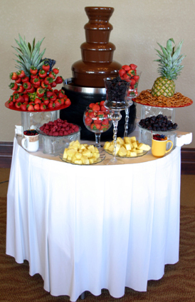

Caramel Fountain $3.50/person
- Served with Red & Green Apples

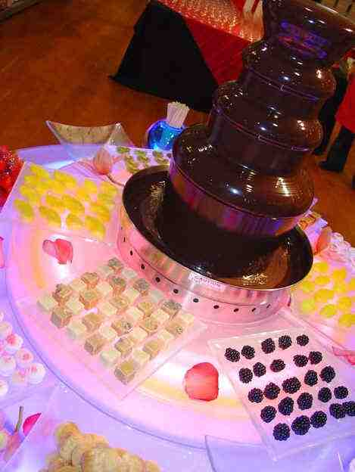

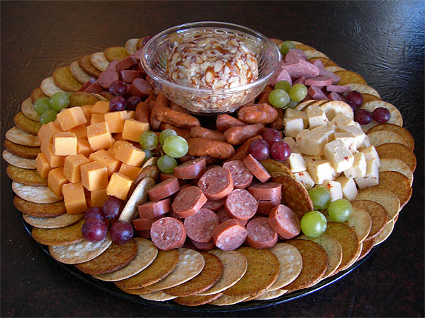

Reception Menu
Priced Per 100 pieces
Artichoke Tarts | $124.00
Assorted Mini Quiche | $98.00
BBQ Meatballs | $92.00
Bacon Wrapped Scallops | $188.00
Beef Wellington | $195.00
Broccoli Cheddar Bites | $124.00
Chicken Fillet Strips | $124.00
Chicken Quesadillas | $135.00
Coconut Shrimp | $190.00
Crab Cakes | $165.00
Chicken & Pineapple Skewers | $157.00
Italian Meatballs | $85.00
Mini Cheesecakes | $165.00
Mini Country Ham Biscuits | $98.00
Mini Desserts | $190.00
Mini Turkey Pot Pie | $136.00
Mozz.Cheese Sticks | $145.00
Olive Bites | $124.00
Peel & Eat Shrimp | $210.00
Pork & Shrimp Egg Rolls | $98.00
Sausage Balls | $52.00
Stuffed Mushrooms | $140.00
Teriyaki Beef Skewers | $185.00
Turkey & Ham Yeast Roll Sandwiches | $98.00
Water Chestnuts in Bacon | $130.00

Wedding Cakes
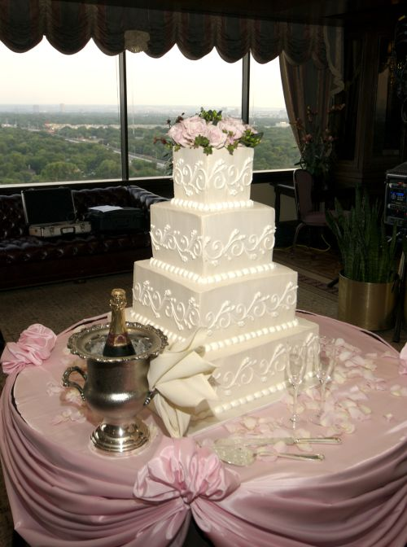

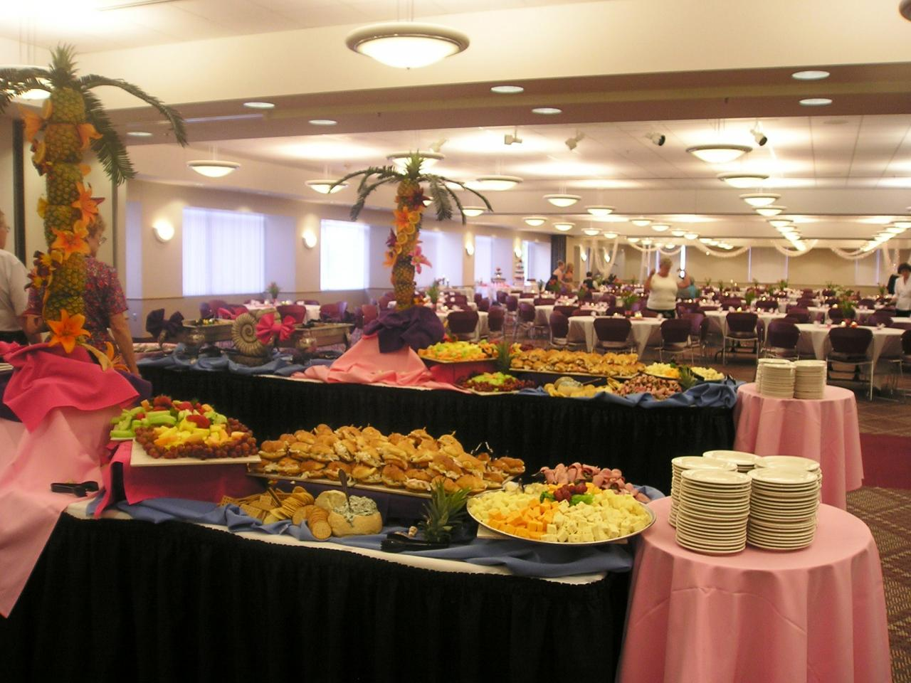

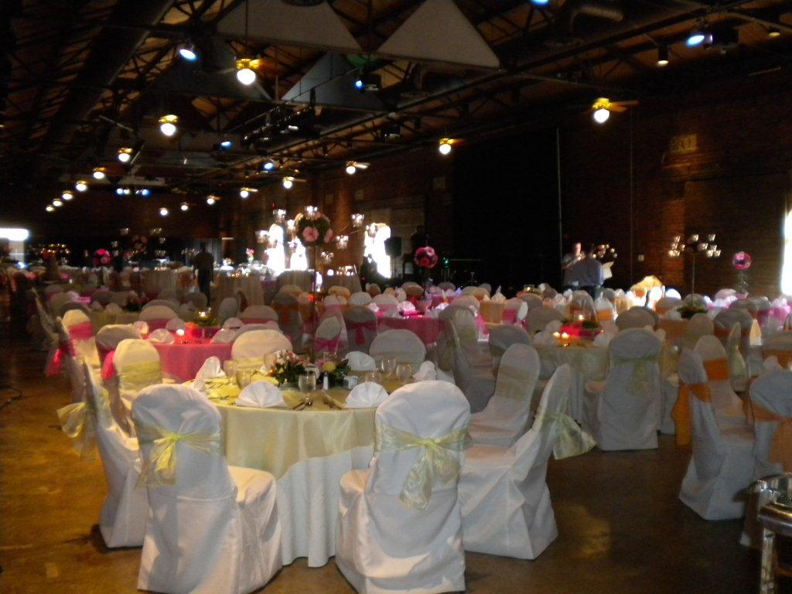

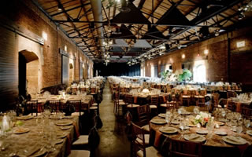

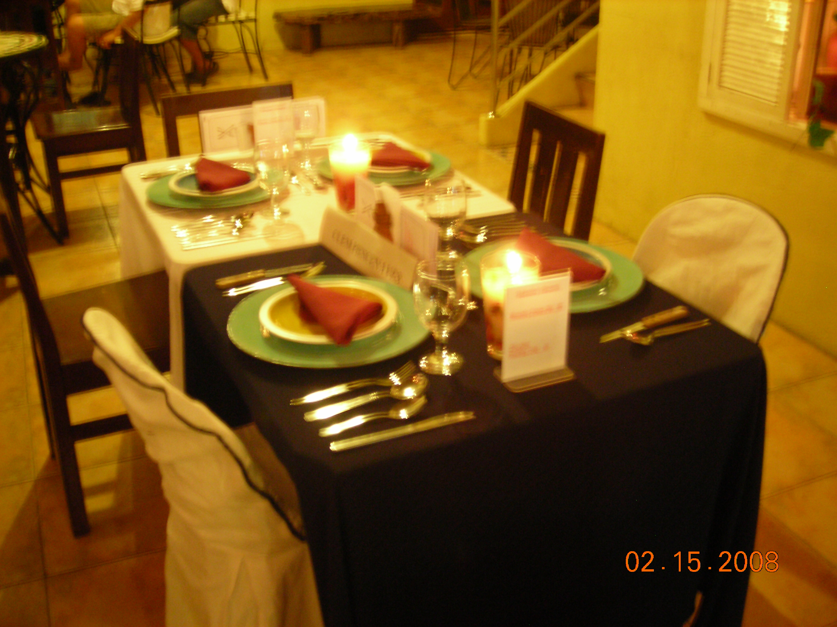

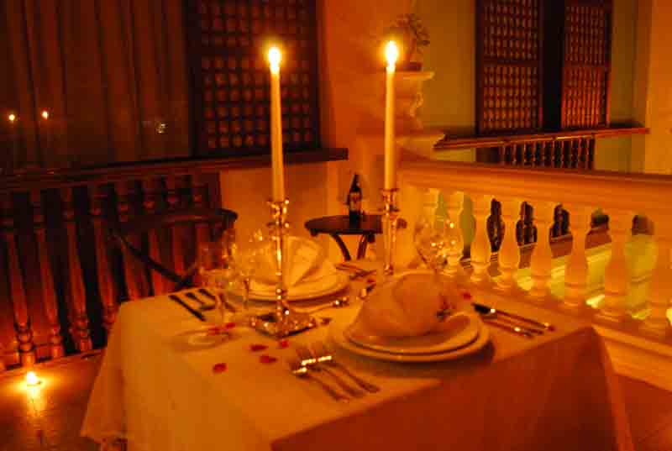



Serving the greater Atlanta area

